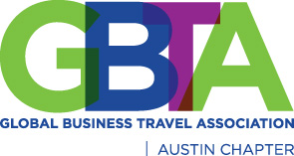
GBTA Austin Holiday Party Charity Donations
December 3rd at Cover3

To get into the giving spirit, we will be collecting donations for charities at our holiday party. Please see the “Wish List” of these two organizations below. We appreciate your support of these worthy causes! Please bring your donations with you to the holiday party and we will deliver them to the organizations.

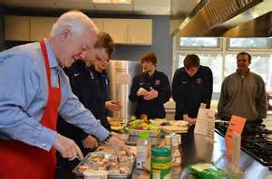
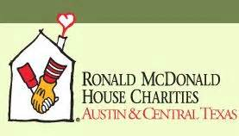
Ronald McDonald House
Paper Towel Rolls
Laundry Detergent
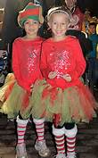
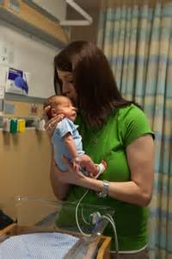
Disposable Paper Cups
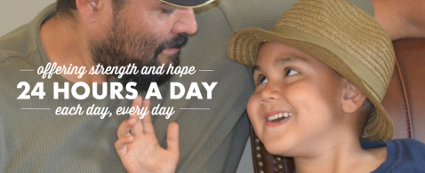
Medium Size Tupperware
Gallon or Quart Size Ziploc Bags
Dishwasher Detergent
All Natural, All Purpose Cleaner
Bulk Sugar
Saran Wrap
Aluminum Foil

Forgotten Friends Mix Breed Rescue
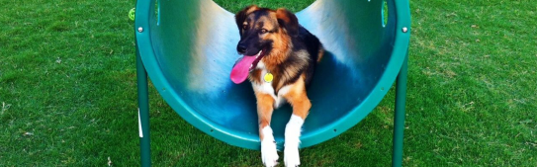
"Please no rawhides or made in China foods or treats."

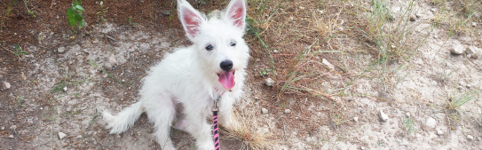
Deer antlers Boar horns Pig ears – made in the USA
Chicken tenders made in the USA
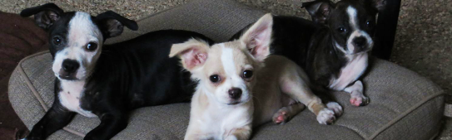
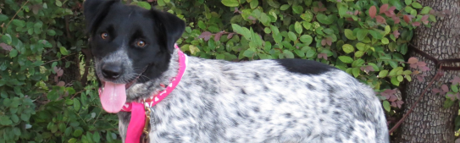
Flexible Nylabones with chicken
Hickory Smoked capsule pill pockets
Merrick's canned dog food
Hi-Tek Naturals dry Chicken Meal and Sweet Potato
Merrick's dry dog food
Back to Basics dry dog food
Small and medium dog collars with snap buckle
Vinyl Toys
Gift cards from:
Tomlinson's Pet Store
Tractor Supply
Petco
Amazon

